Decoding a QR Code Manually

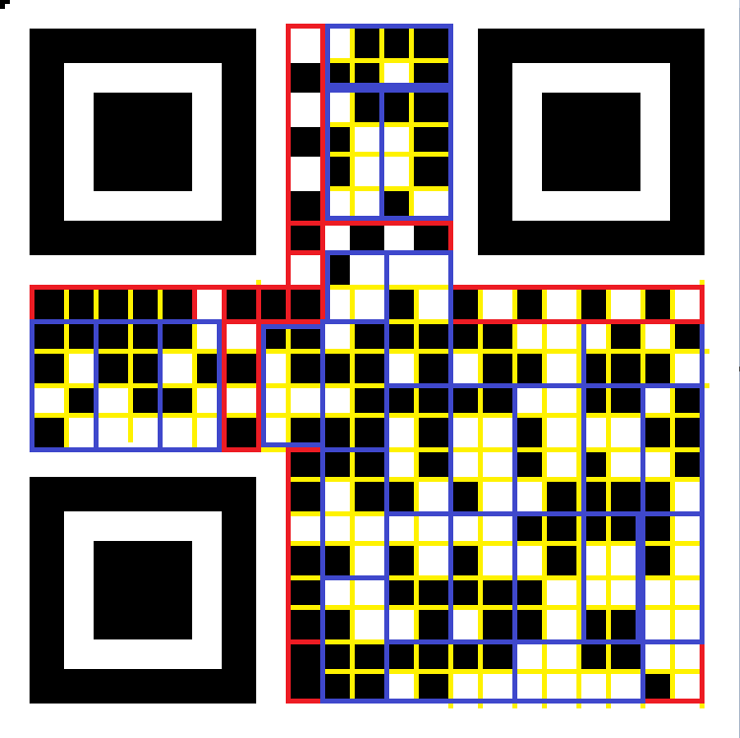

1. Find the format information

11111 ^ 10101 = 01010, -> 01 for error correction, 010 for mask bits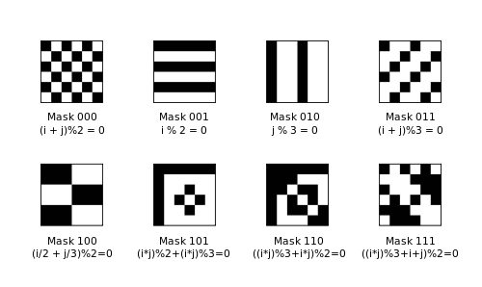

**Mask 010 has first column, to be inverted, next two columns to remain as it is.**

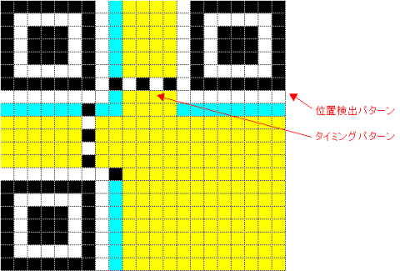

**Yellow part is Data**

**Blue Part if QR Code Information**

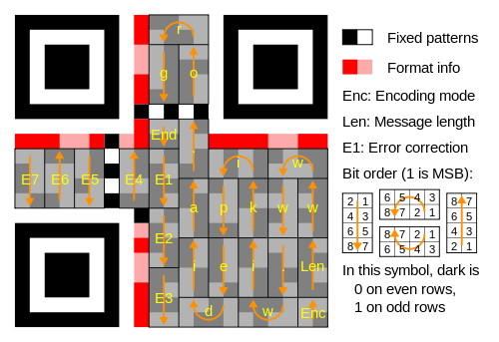

**Data should be read according to these arrows**

**Start Reading from bottom right**

**Encoding Bits**

Here's the table of encoding types:

* 0001 Numeric
* 0010 Alphanumeric
* 0100 8-bit Byte

**We have, 0100 – reading 8-bit byte**

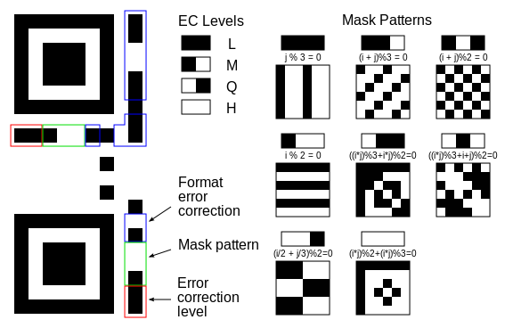

**In the given QR code, ‘L’ error correction is used.**

**Error Correction Capability**

**Recovers 7% of data**

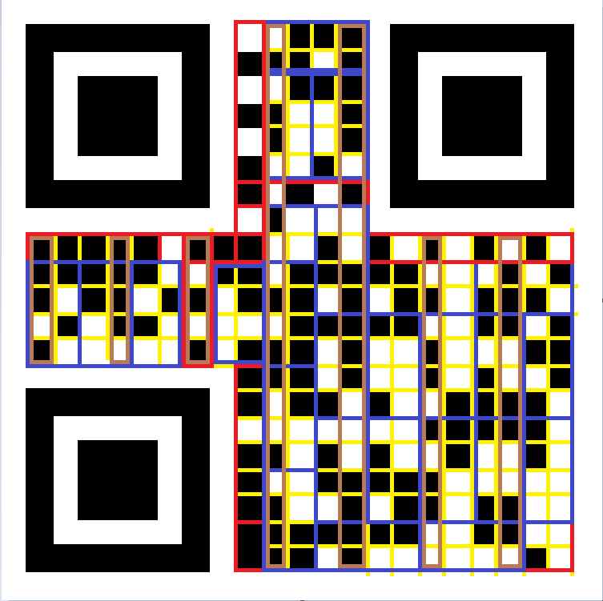

|  |  |  |  |  |  |
| --- | --- | --- | --- | --- | --- |
| **Block No.** | **Binary** | **After masking** | **Decimal** |  | **Meaning** |
|  | **00000101** |  | **5** | **Length of message** | **Message is 5 bytes long** |
| **1** | **01101110** |  | **110** | **Text** | **n** |
| **2** | **01101011** | **01100001** | **97** | **Text** | **a** |
| **3** | **11000111** | **01101101** | **109** | **Text** | **m** |
| **4** | **11000011** | **01101001** | **105** | **Text** | **i** |
| **5** | **11000000** | **01100101** | **101** | **Text** | **e** |
|  | **01011011** | **00001110** | **14** |  |  |
|  | **10010100** | **11000000** | **192** |  | **Á** |
|  | **01001110** | **00011110** | **30** |  |  |
|  | **11000001** |  | **193** |  | **Á** |
|  | **00011110** |  | **30** |  |  |
|  | **11001011** | **11000001** | **193** |  | **Á** |
|  | **10110100** | **00011110** | **30** |  |  |
|  | **01101011** | **11000001** | **193** |  | **Á** |
|  | **10110100** | **00011110** | **30** |  |  |
|  | **01101011** | **11000001** | **193** |  | **Á** |
|  | **10111011** | **00011110** | **30** |  |  |
|  | **10010100** | **11000001** | **193** |  | **Á** |
|  | **0100** | **0001** | **1** | **END** |  |
|  | **10111011** | **11101110** | **238** | **E1** | **î** |
|  | **11100001** | **10110100** | **180** | **E2** | **´** |
|  | **00011111** | **01001010** | **74** | **E3** | **J** |
|  | **10001011** |  | **139** | **E4** |  |
|  | **01100100** |  | **100** | **E5** | **d** |
|  | **00101111** | **10000101** | **133** | **E6** |  |
|  | **11011001** | **10001100** | **140** | **E7** |  |

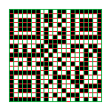

(Tampered QR Code, from aaron to gibberish text)

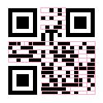

Tampered QR Code (from abacus to gibberish text)